Merge Conflict Resolution

Aim:
To understand how to create and resolve merge conflicts in Git by merging changes from different branches into the main branch.
Tools Required:
- Git Bash
- GitHub
- Notepad / Notepad++
- Windows PC
- Existing Git Repository (GitDemo)
Procedure:
- Verify that the main branch is in a clean state.
- Create a new branch named GitWork.
- Create and modify hello.xml in the GitWork branch.
- Commit the changes in the branch.
- Switch to the main branch.
- Create and modify hello.xml with different content.
- Commit the changes in the main branch.
- View the commit history and compare the branch differences.
- Merge the GitWork branch into the main branch.
- Resolve the merge conflict by editing hello.xml.
- Commit the resolved changes.
- Update the .gitignore file.
- Commit the updated .gitignore.
- Verify the branch status and view the commit history.
Commands Used:
cd ~/GitDemo
git status
git branch GitWork
git checkout GitWork
echo "<message>Hello from GitWork</message>" > hello.xml
git add hello.xml
git commit -m "Added hello.xml in GitWork"

git checkout main
echo "<message>Hello from Main Branch</message>" > hello.xml
git add hello.xml
git commit -m "Added hello.xml in main"

git log --oneline --graph --decorate --all
git diff main GitWork
git merge GitWork

git add hello.xml
git commit -m "Resolved merge conflict"

echo *.bak >> .gitignore
git add .gitignore
git commit -m "Updated .gitignore"

git branch
git log --oneline --graph --decorate
git push

Outputs:
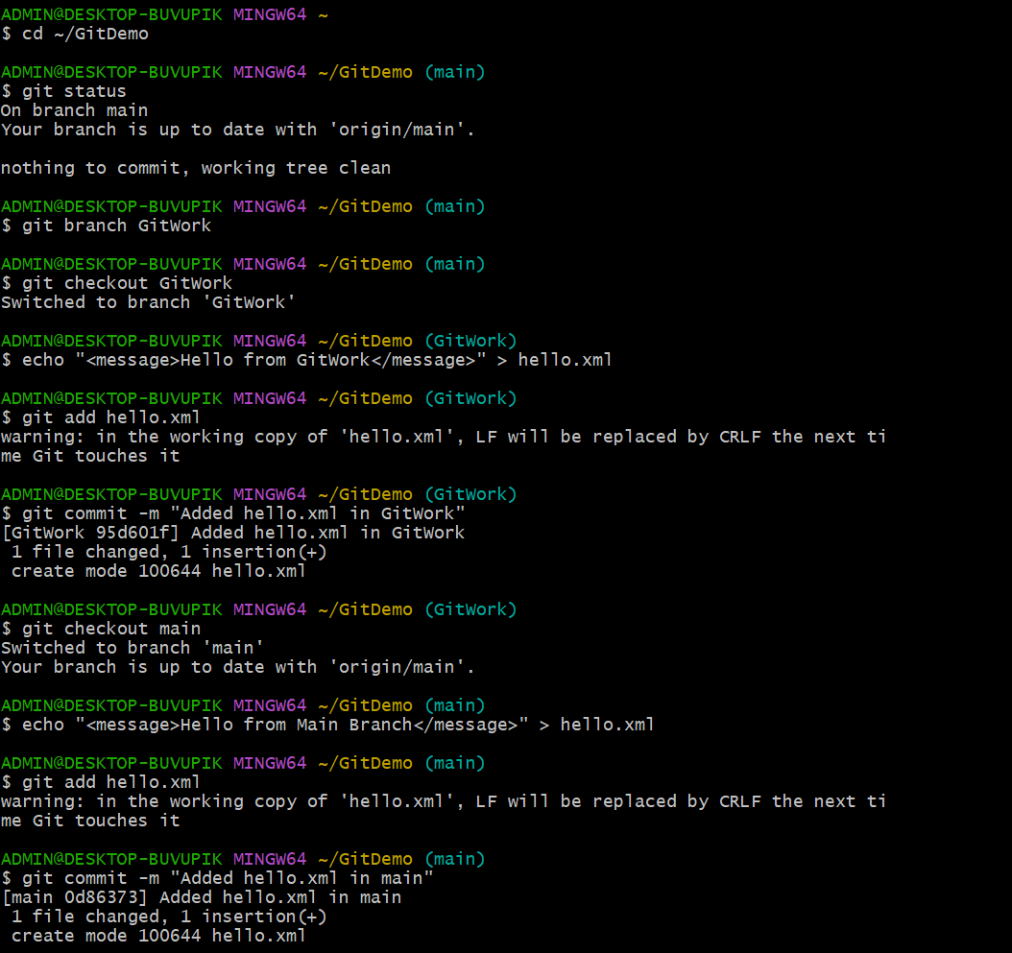
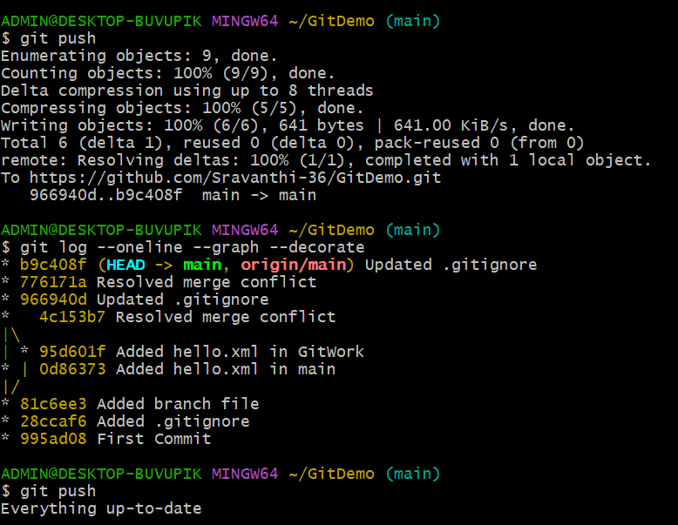
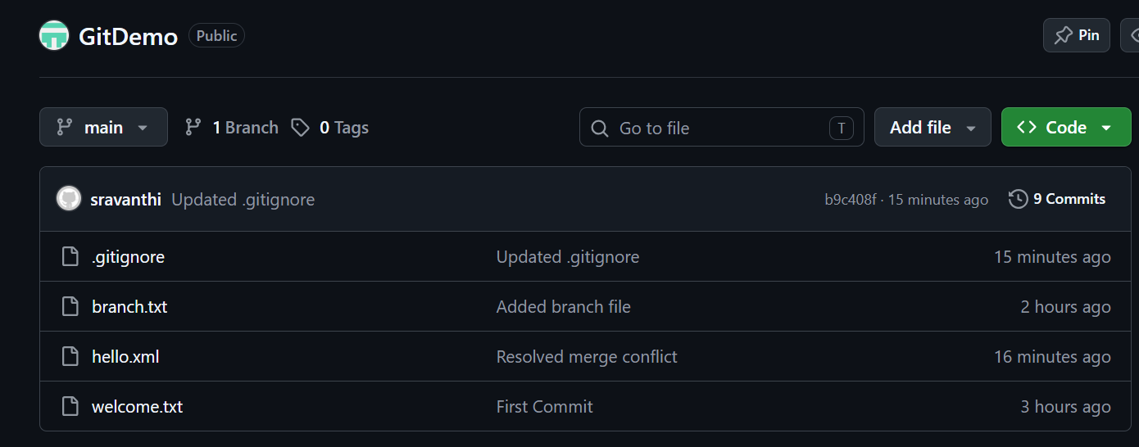
Result:
Successfully created a merge conflict, resolved the conflict by editing the conflicting file, updated the .gitignore file, committed the resolved changes, and synchronized the repository with GitHub.

